**22100409 Siaw Jia Yuin**

**LL1 Parser**

**BNF**

S -> BEGIN_BLOCK BEGIN_STMT

BEGIN_BLOCK -> program PROGRAM_NAME

PROGRAM_NAME -> id

BEGIN_STMT -> begin STMT* end

STMT -> DECLARATION

| IF_STMT

| PRINT_STMT

| WHILE_STMT

| FOR_STMT

| BREAK_STMT

DECLARATION -> int OPERATOR ;

| OPERATOR ,

OPERATOR -> id = OP_STMT

| OP_STMT

OP_STMT -> TERM

| OP_STMT + TERM

| id ++

TERM -> TERM * FACTOR

| FACTOR

FACTOR -> number_literal

| id

PRINT_CONTENT -> string_literal

| id

IF_STMT -> if ( COM_STMT ) BEGIN_STMT

| if ( COM_STMT ) BEGIN_STMT else_if ( OP_STMT ) BEGIN_STMT

| if ( COM_STMT ) BEGIN_STMT else_if ( OP_STMT ) BEGIN_STMT else BEGIN_STMT

PRINT_STMT -> print_line ( PRINT_CONTENT ) ;

| display ( PRINT_CONTENT ) ;

WHILE_STMT -> while ( STMT ) BEGIN_STMT

FOR_STMT -> for ( STMT ) BEGIN_STMT

BREAK_STMT -> break ;

COM_STMT -> LT_STMT

| EQ_STMT

LT_STMT -> FACTOR < FACTOR

EQ_STMT -> FACTOR == FACTOR

**BNF without Left Recursion**

S -> BEGIN_BLOCK BEGIN_STMT

BEGIN_BLOCK -> program id

BEGIN_STMT -> begin STMTS end

STMTS -> STMT STMTS

STMTS -> ''

STMT -> DECLARATION_LIST

STMT -> IF_STMT

STMT -> PRINT_STMT

STMT -> WHILE_STMT

STMT -> FOR_STMT

STMT -> BREAK_STMT

DECLARATION_LIST -> DECLARATION DECLARATION_LIST'

DECLARATION_LIST -> ‘’

DECLARATION_LIST' -> , DECLARATION DECLARATION_LIST’

DECLARATION_LIST' -> ''

DECLARATION -> TYPE ID_LIST ;

DECLARATION -> ID_LIST ;

TYPE -> int

TYPE -> integer

ASSIGNMENT -> = OP_STMT

ASSIGNMENT -> ‘’

ID_LIST -> id ASSIGNMENT ID_LIST'

ID_LIST' -> , id ASSIGNMENT ID_LIST'

ID_LIST' -> ''

OP_STMT -> TERM OP_STMT'

OP_STMT' -> + TERM OP_STMT'

OP_STMT’ -> ++

OP_STMT' -> ''

TERM -> FACTOR TERM'

TERM' -> * FACTOR TERM'

TERM' -> ''

FACTOR -> number_literal

FACTOR -> id

PRINT_CONTENT -> string_literal

PRINT_CONTENT -> identifier

IF_STMT -> if ( COM_STMT ) BEGIN_STMT IF_STMT'

IF_STMT' -> else_if ( COM_STMT ) BEGIN_STMT IF_STMT'

IF_STMT' -> else BEGIN_STMT

IF_STMT' -> ''

PRINT_STMT -> print_line ( PRINT_CONTENT ) ;

PRINT_STMT -> display ( PRINT_CONTENT ) ;

WHILE_STMT -> while ( COM_STMT ) BEGIN_STMT

FOR_STMT -> for ( DECLARATION COM_STMT ; OP_STMT ) BEGIN_STMT

BREAK_STMT -> break ;

COM_STMT -> TERM COM_STMT’

COM_STMT’ -> < FACTOR

COM_STMT’ -> == FACTOR

COM_STMT’ -> ‘’

**First Set**

S = {program}

BEGIN_BLOCK = {program}

BEGIN_STMT = {begin}

STMTS = { /eps, if, print_line, display, while, for, break, int, integer, id }

STMT = { /eps, if, print_line, display, while, for, break, int, integer, id }

DECLARATION_LIST = { /eps, int, integer, id }

DECLARATION_LIST’ = { /eps , , }

DECLARATION = { int, integer, id }

TYPE = { int, integer }

ASSIGNMENT = { =, /eps }

ID_LIST = {id}

ID_LIST’ = { , , /eps }

OP_STMT = { number_literal, id }

OP_STMT’ = { +, ++, /eps }

TERM = { number_literal, id }

TERM’ = { *, /eps }

FACTOR = { number_literal, id }

PRINT_CONTENT = { string_literal, id }

IF_STMT = { if }

IF_STMT’ = { else_if, else, /eps }

PRINT_STMT = { print_line, display }

WHILE_STMT = { while }

FOR_STMT = { for }

BREAK_STMT = { break }

COM_STMT = { number_literal, id }

COM_STMT’ = { <, ==, /eps }

**Follow Set**

S = { $ }

BEGIN_BLOCK = { begin }

BEGIN_STMT = { $, else_if, else, end, if, print_line, display, while, for, break, int, integer, id }

STMTS = { end }

STMT = { end, if, print_line, display, while, for, break, int, integer, id }

DECLARATION_LIST = { end, if, print_line, display, while, for, break, int, integer, id }

DECLARATION_LIST’ = { end, if, print_line, display, while, for, break, int, integer, id }

DECLARATION = { end, if, print_line, display, while, for, break, int, integer, id, , ,DECLARATION_LIST’, number_Literal }

TYPE = { id }

ASSIGNMENT = { , , ; }

ID_LIST = {;}

ID_LIST’ = { ; }

OP_STMT = { ), , , ; }

OP_STMT’ = { ), , , ; }

TERM = { +, ++, <, ==, ), ;, , }

TERM’ = { +, ++, <, ==, ), ;, , }

FACTOR = { *, +, ++, ), ;, <, ==, , }

PRINT_CONTENT = { ) }

IF_STMT = { end, if, print_line, display, while, for, break, int, integer, id }

IF_STMT’ = { end, if, print_line, display, while, for, break, int, integer, id }

PRINT_STMT = { end, if, print_line, display, while, for, break, int, integer, id }

WHILE_STMT = { end, if, print_line, display, while, for, break, int, integer, id }

FOR_STMT = { end, if, print_line, display, while, for, break, int, integer, id }

BREAK_STMT = { end, if, print_line, display, while, for, break, int, integer, id }

COM_STMT = { ), ; }

COM_STMT’ = { ), ; }

**Parsing Table** 

**Program Output**

1. Test1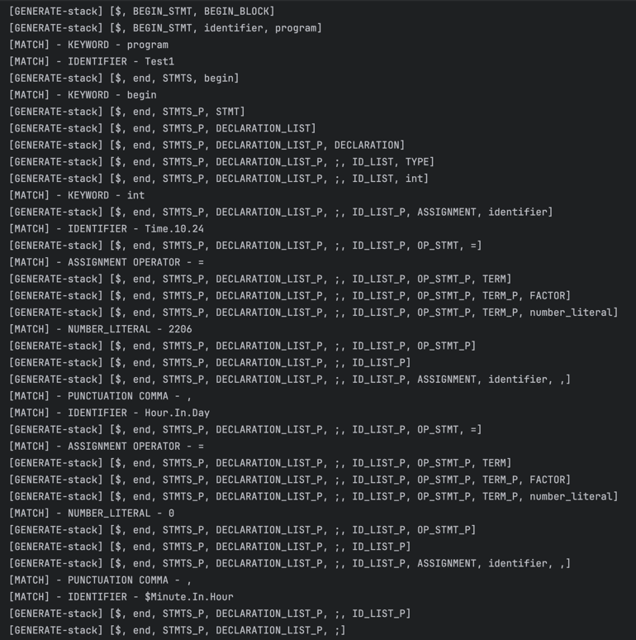A screenshot of a computer program

   Description automatically generatedA screen shot of a computer

   Description automatically generatedA screen shot of a computer

   Description automatically generated
2. Test1error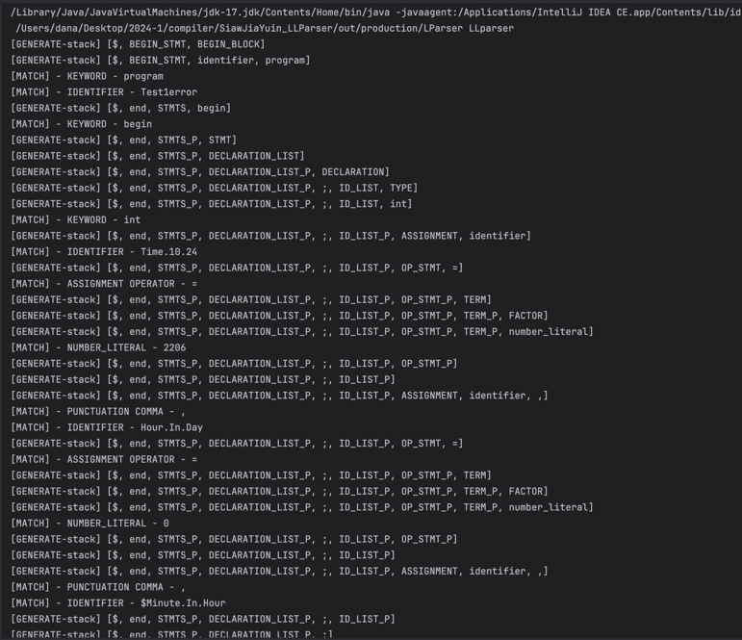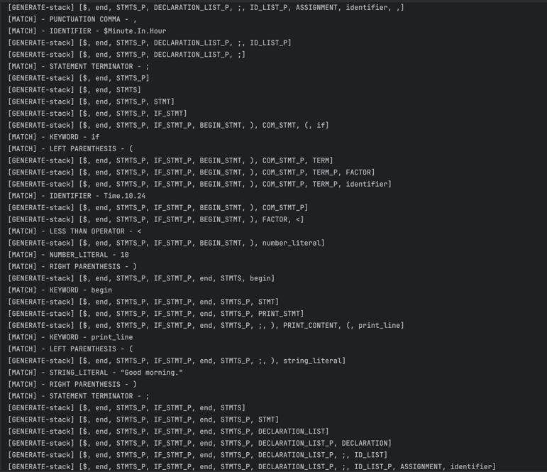A computer screen shot of white text

   Description automatically generated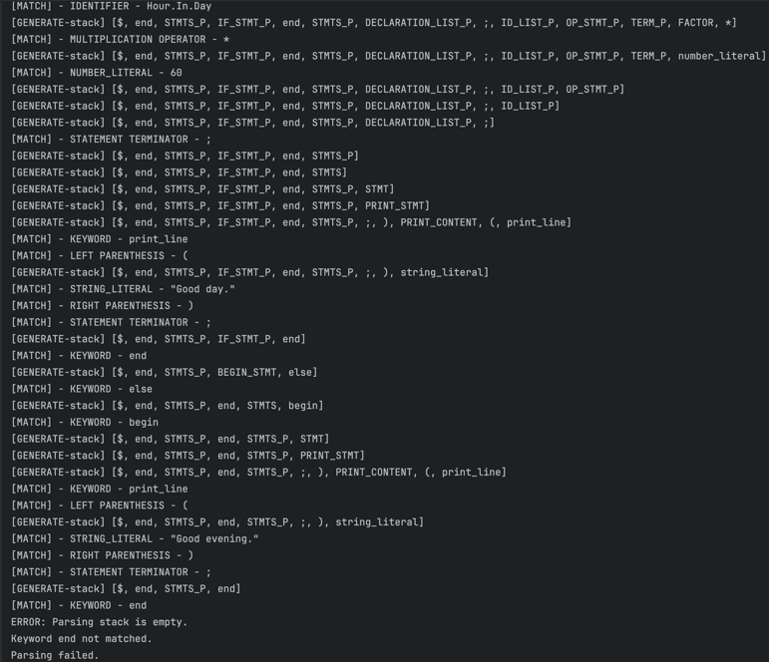
3. Test2

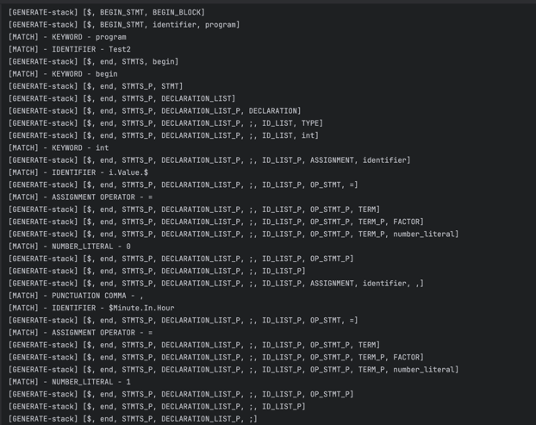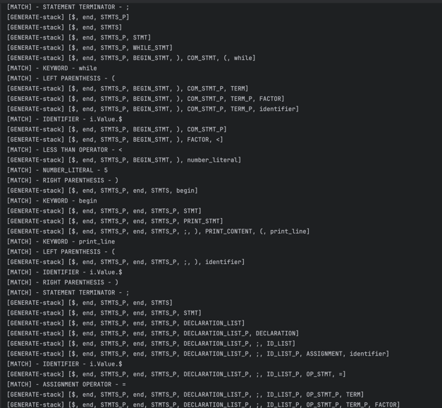

1. Test2error

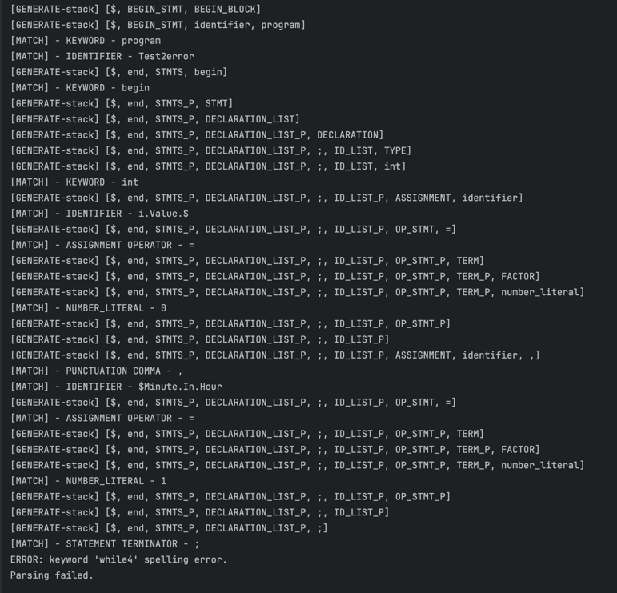

1. Test3

1. Test3error

